Daily Assessment

Name : Chakradhar Bhogapurapu

Date : 04/01/2024

Mail : [chakribhogapurapu@gmail.com](mailto:chakribhogapurapu@gmail.com)

Topic : ETL workload on Azure Databricks

🡪Create a Databricks workspace name it as “AZWS914”.

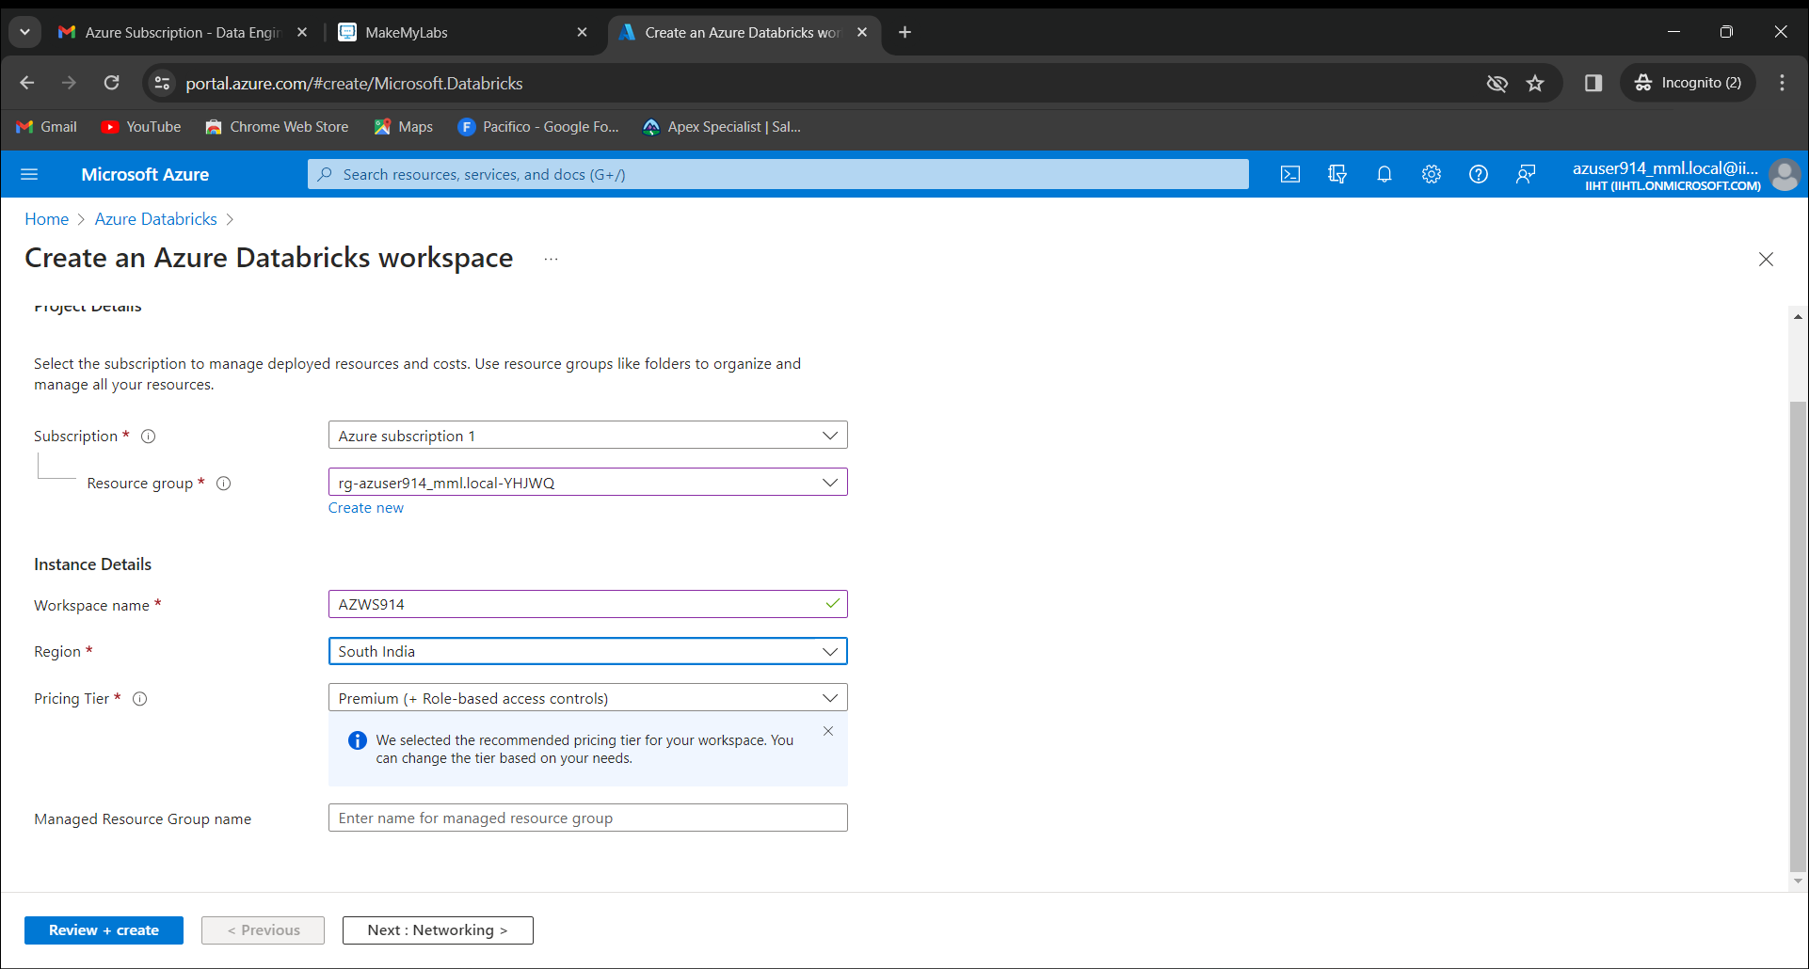

After creating the workspace we need to launch it. Create a cluster in it name it as “azuser914_Cluster”.

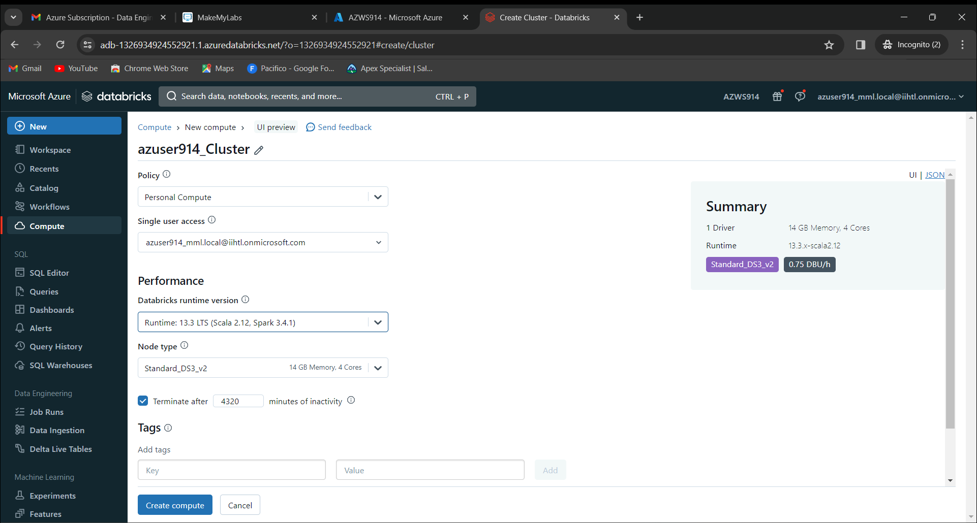

Now create the notebook name it as “Notebook1”. Select the default language as Python.

Execute the commands and run the cells individually.

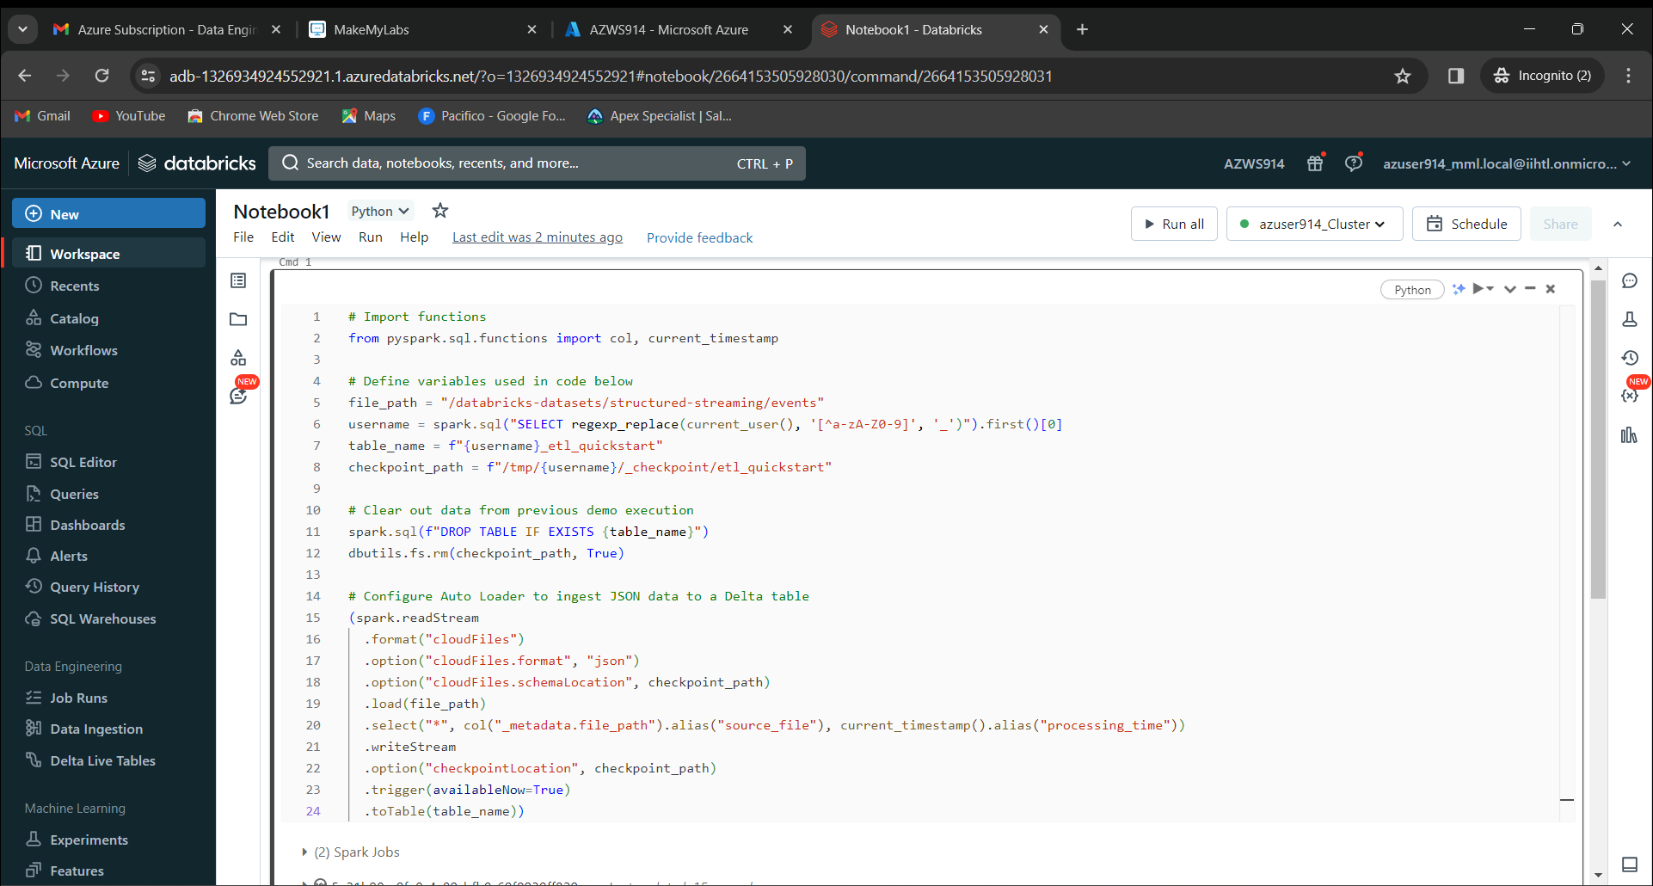

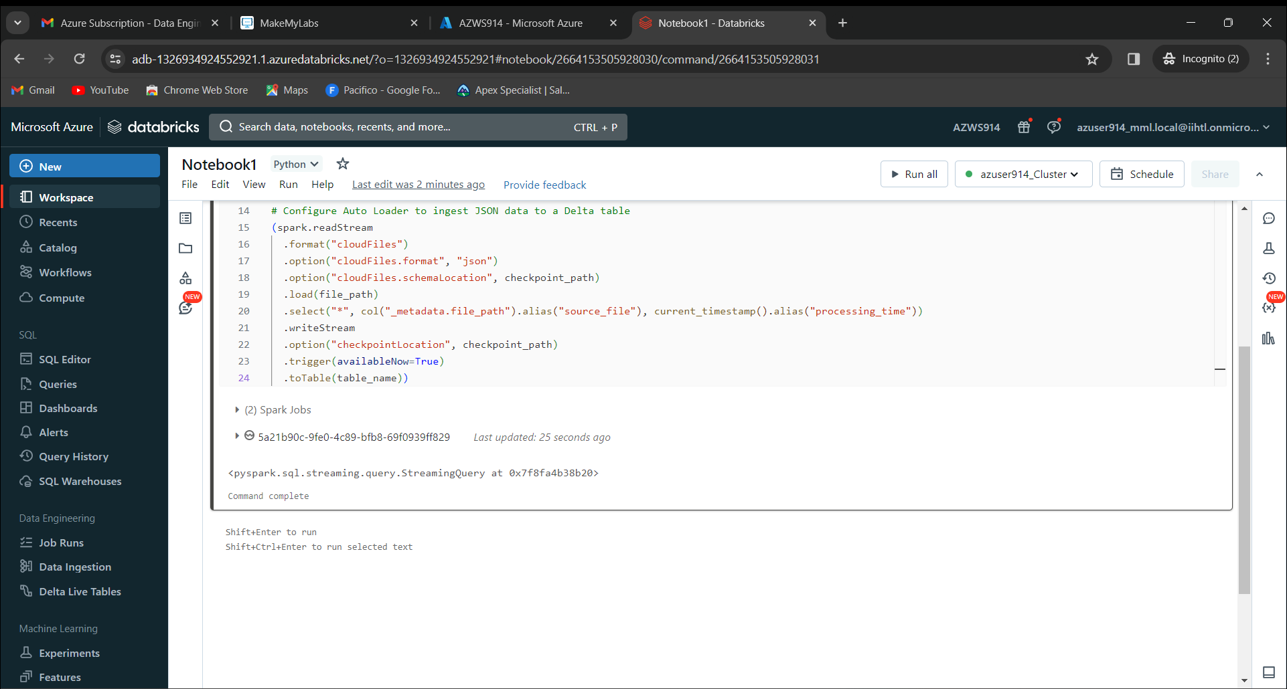

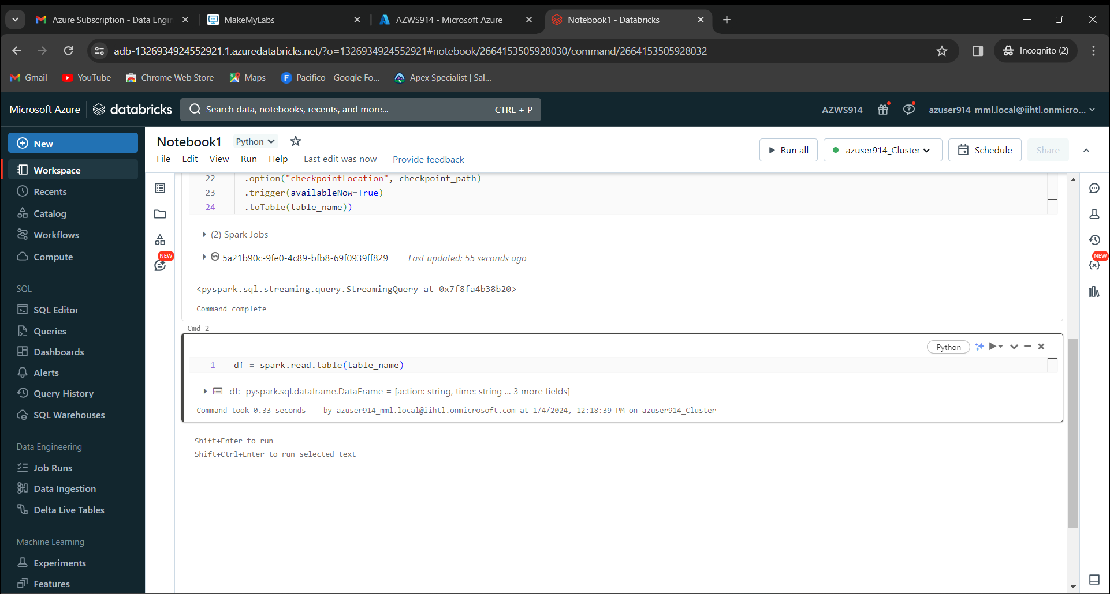

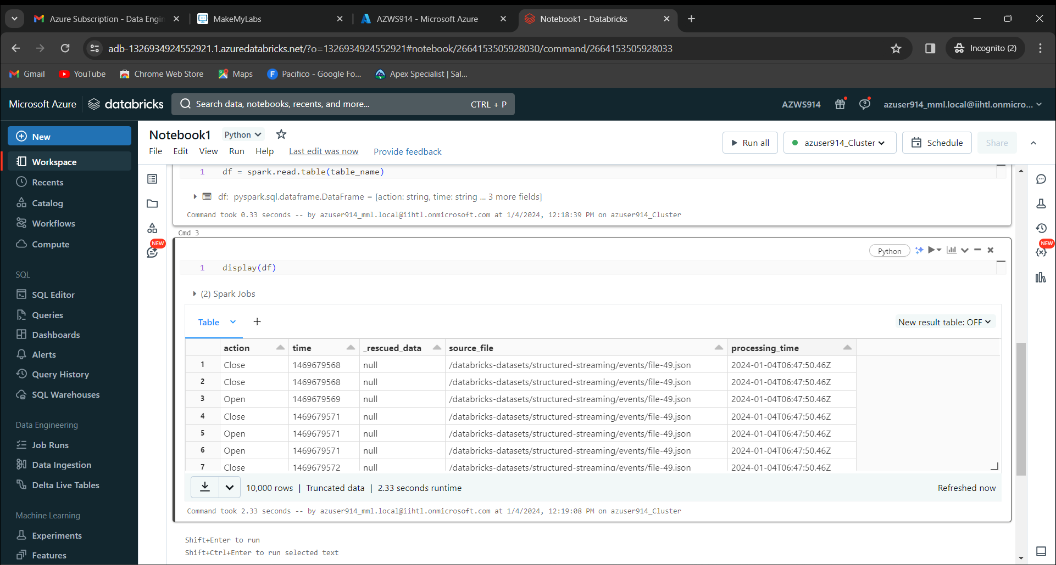

Now click on schedule. 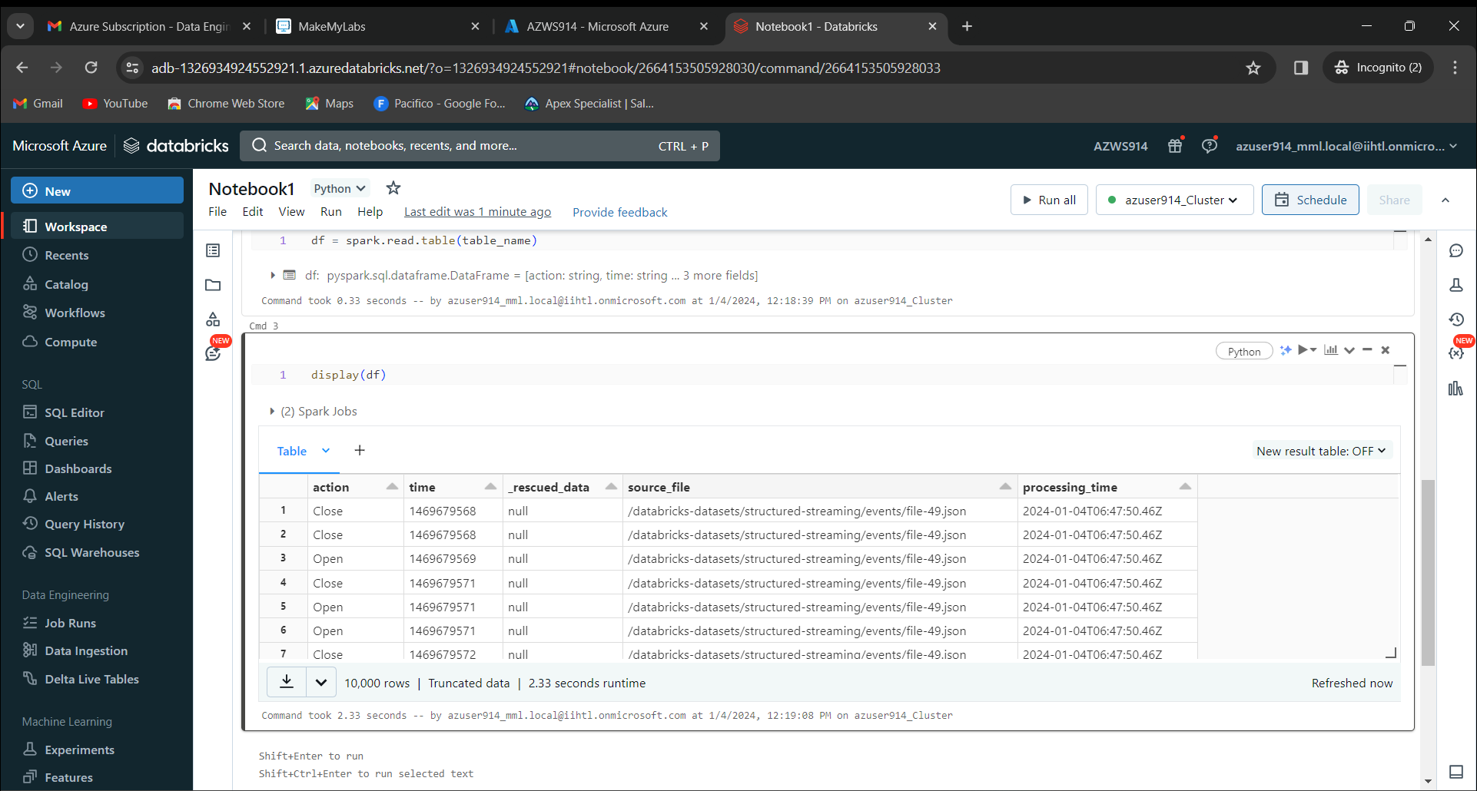

Give the job name as “Notebook1_jobs”

Schedule as Manual

Now click on create

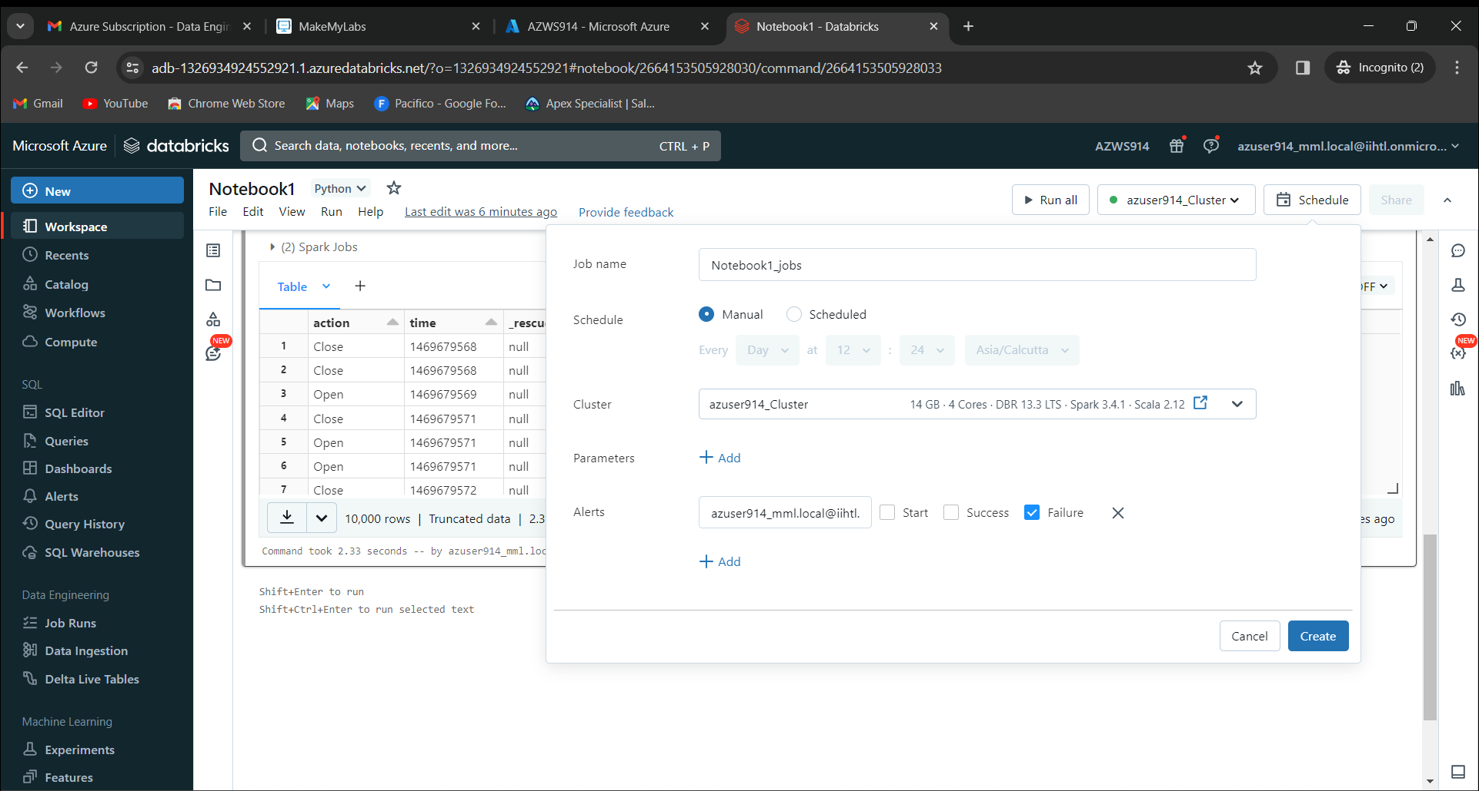

Click on “Run Now” 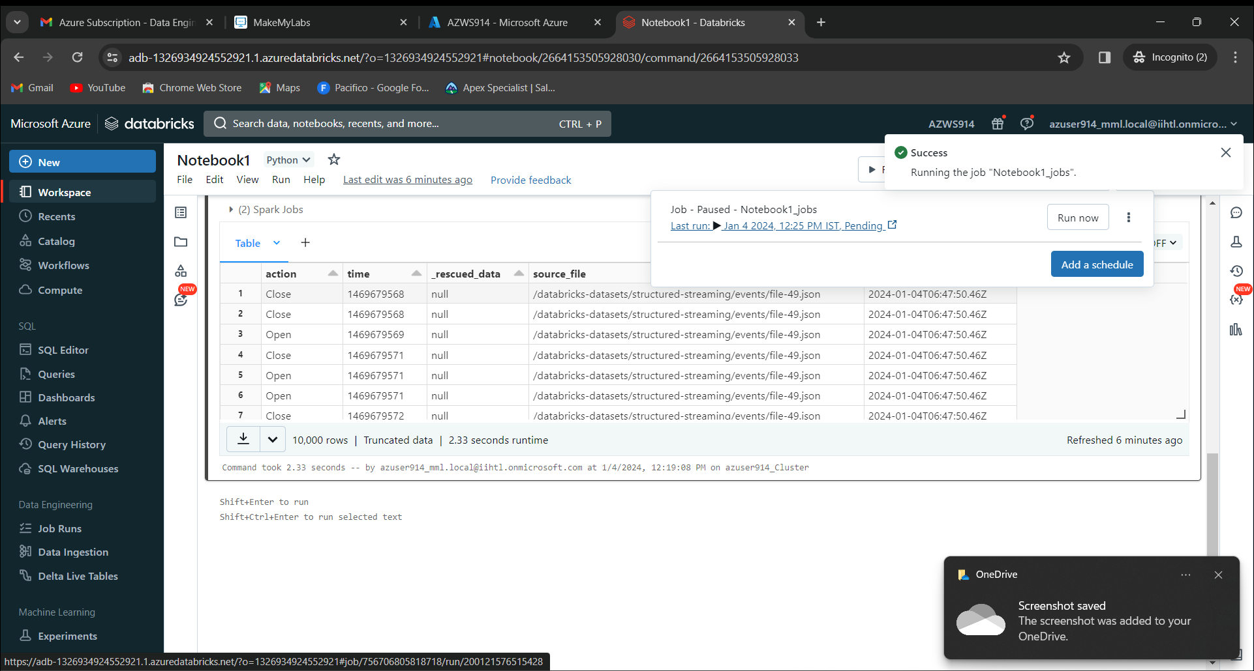

Now open that page in new tab. We get the output.

